**UseCase Diagram:**



**Class Diagram:**



**Sequence Diagram:**



**fig:sequence diagram for Admin**



**fig: sequence diagram for User**

**Collaboration Diagram:**

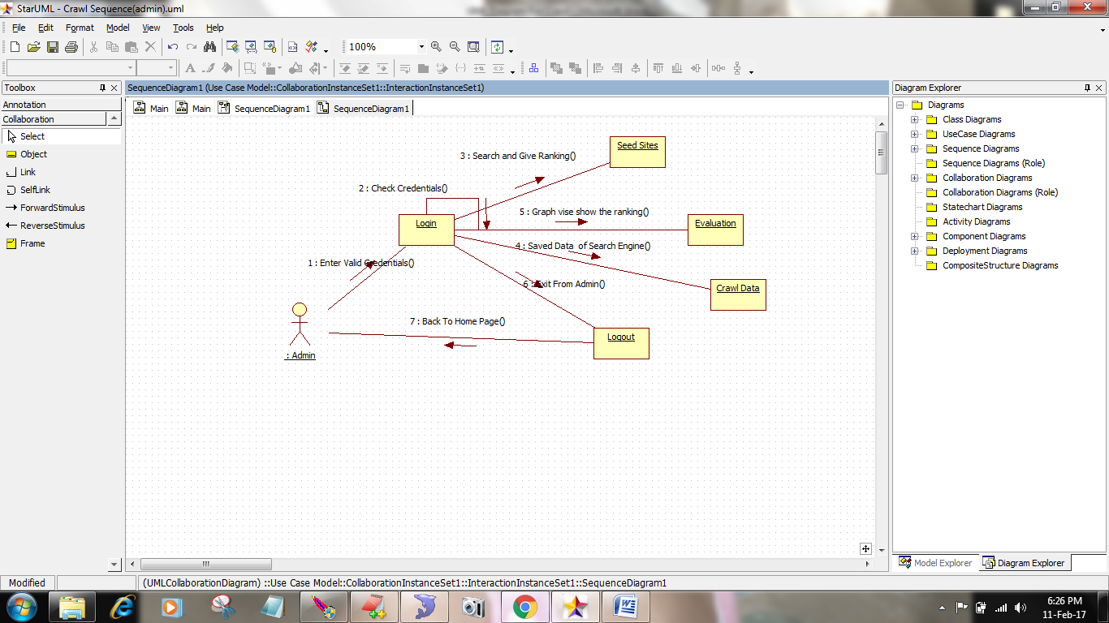

**fig: Collaboration diagram for Admin**

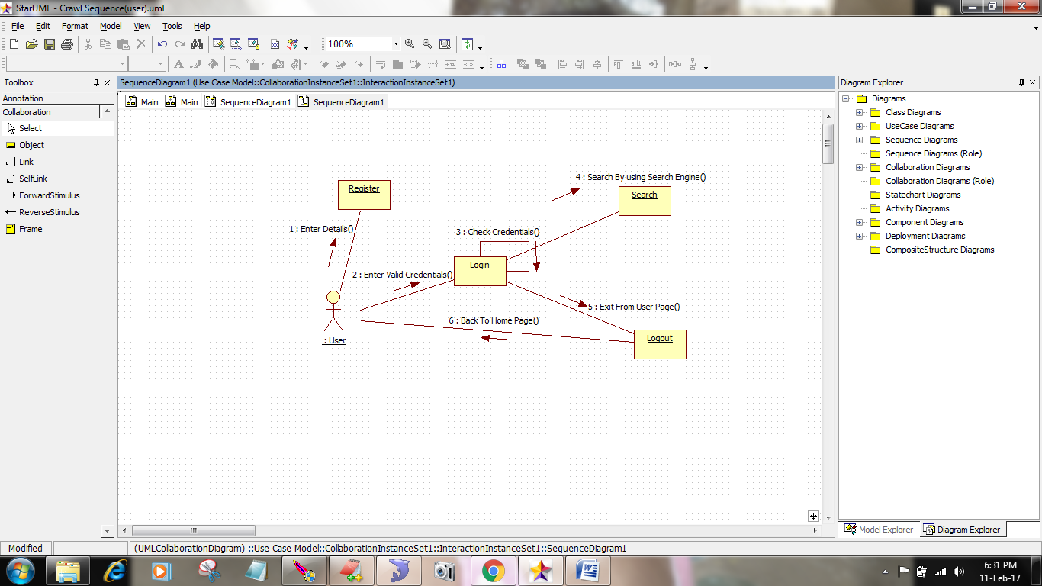

**fig: Collaboration diagram for User**

**Activity Diagram:**



**State Chart Diagram:**



**Component Diagram:**



**Deployement Diagram:**

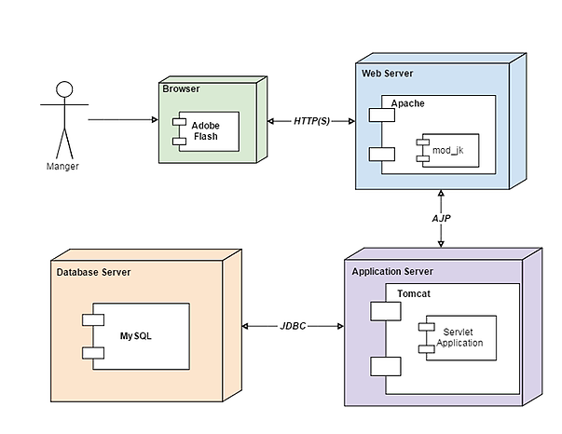

**E-R Diagram:**

